From: Sara Kozel <sara@maacama.com>
Date: 4 August 2012 09:49:08 PDT
To: Sara Kozel <sara@maacama.com>, Dan Lynch <dan@lynch.com>, "Ole Jacobsen (ole)" <ole@cisco.com>, Dan Lynch <dori@lynch.com>
Subject: MAP to the INTEROP REUNION - Saturday 11 August

Saturday 11 August 2012
12 noon - 6pm

Reunion and Barbecue along the Maacama Creek

6325 Briggs Ranch Road, Calistoga CA 94515

The party will be held on the Starry Skies Ranch between Healdsburg and Calistoga off Hwy 128 in Sonoma County.

Significant other, children and dogs welcome.

Bring photos, JPEGs on your memory stick, memorabilia so we can all share

The barn is in a field, so comfortable shoes and casual attire are best.

Bring sunscreen and if you are bringing kids who might end up in the creek, a towel and change of clothes (-:

THE MAP:

http://links.derekkozel.com/BarnMap

Most GPS Systems are able to find this address but you should check yours before departing if you are depending on it! Once you arrive at the entry gate to Briggs Ranch Road on Hwy 128, you will drive through the gate and continue about 1 mile. On the left side, you will see cones and flags directing you to the parking field where you can park and walk across the creek to the Party Barn. If you have mobility issues and would like to drive up to the barn, please reply to this message and I will direct you on where you can drive over the creek.

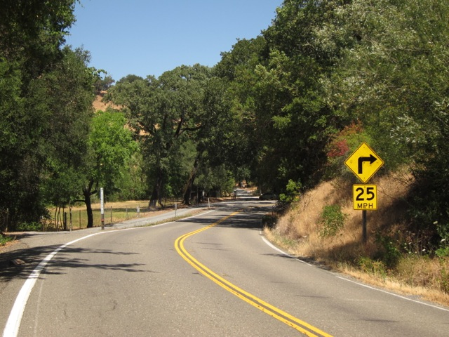

WHAT YOU WILL SEE COMING EAST ON 128--TURNOFF TO BRIGGS RANCH ROAD
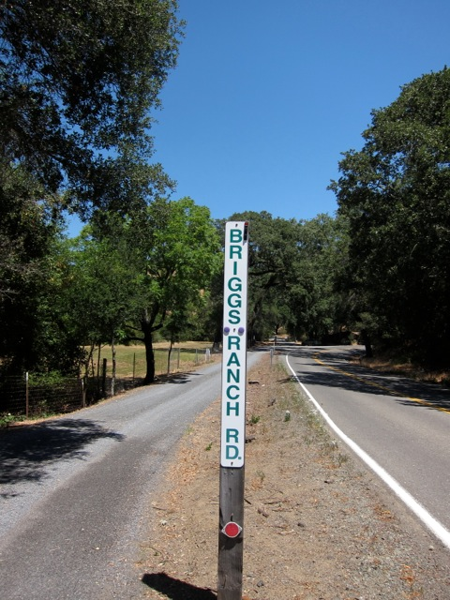

THE SIGNPOST WHERE YOU TURN IN

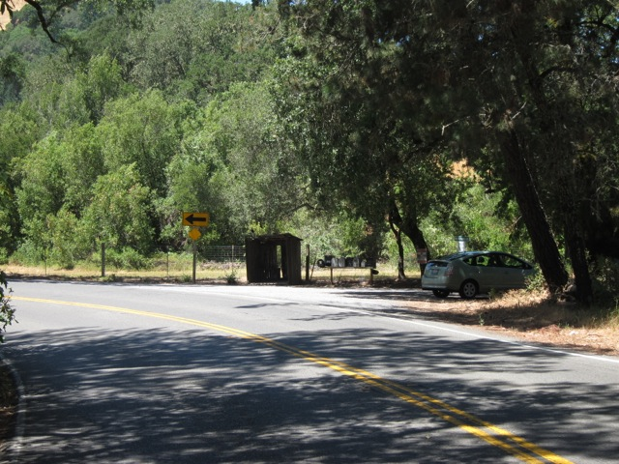

WHAT YOU WILL SEE COMING WEST ON 128--TURNOFF TO BRIGGS RANCH ROAD

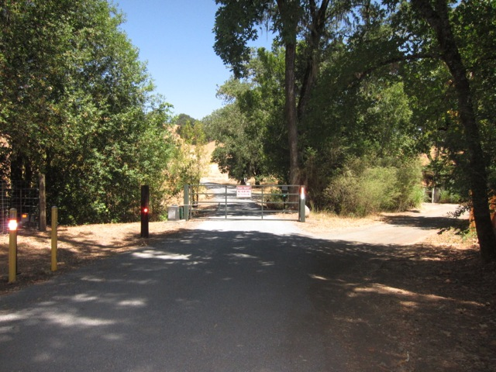

THE GATE TO BRIGGS RANCH ROAD - OPEN THE DAY OF THE PARTY
